**How to use Production Optimization solution?**

1. PI AF
   1. Unzip the file “Production_Optimization_Library.zip”
   2. Import all the library items to your Asset’s Functional Calculations database as per the categories and in the same order.

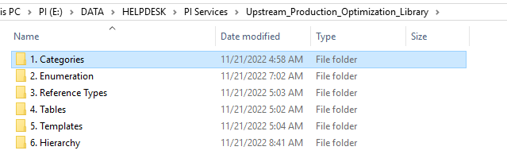

For e.g., Import the Element templates to Library à Templates à Element Templates

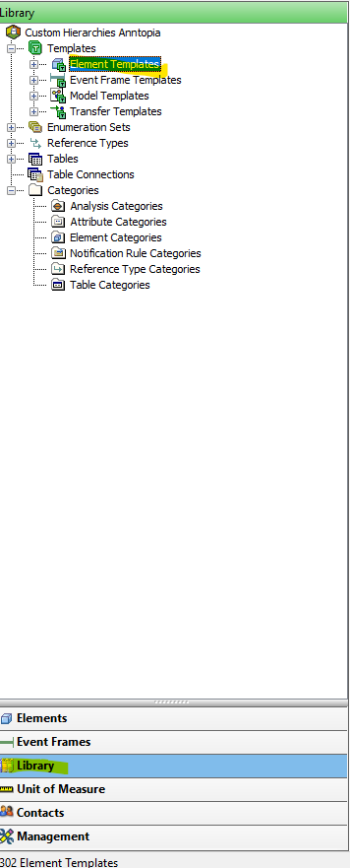

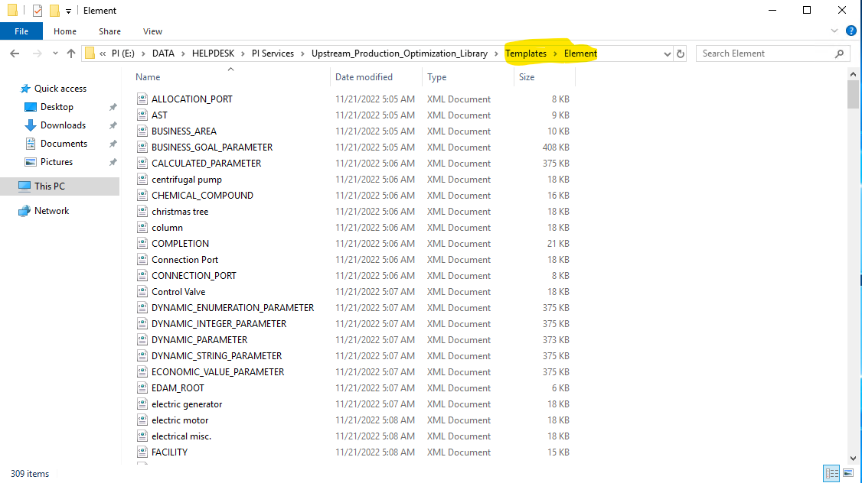

* 1. Import the Hierarchy.xml to Elements

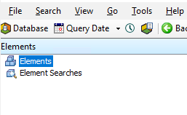

* 1. Update column H in the file, with the respective tags from your asset and export to your Asset’s Functional Calculations database.
  2. Start all the Analyses.

1. PI Vision
   1. Using PI Vision Utility, copy the displays from the folder, **PI Vision Displays\PI COE\PI Services Solutions\ProductionOptimization** to your Asset folder.
   2. Using PI Vision Utility, map all the displays in your Asset folder to Asset’s Functional Calculations database.

